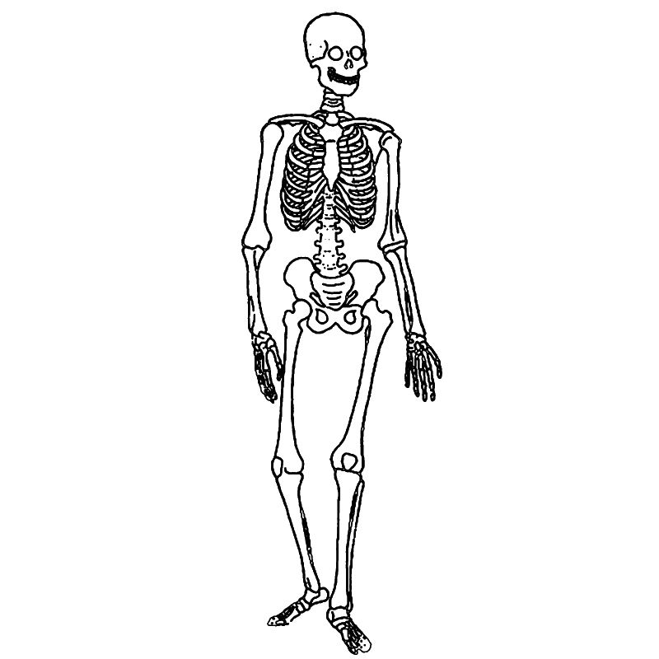
- Phalanges (use this twice) 10. Rib Cage 19. Humerus
- Metatarsals 11. Ulna
- Metacarpals 12. Radius
- Carpals 13. Fibula
- Tarsals 14. Femur
- Tibia 15. Pelvis
- Cranium 16. Patella
- Sternum 17. Vert3brae
- Clavicle 18. Scapula
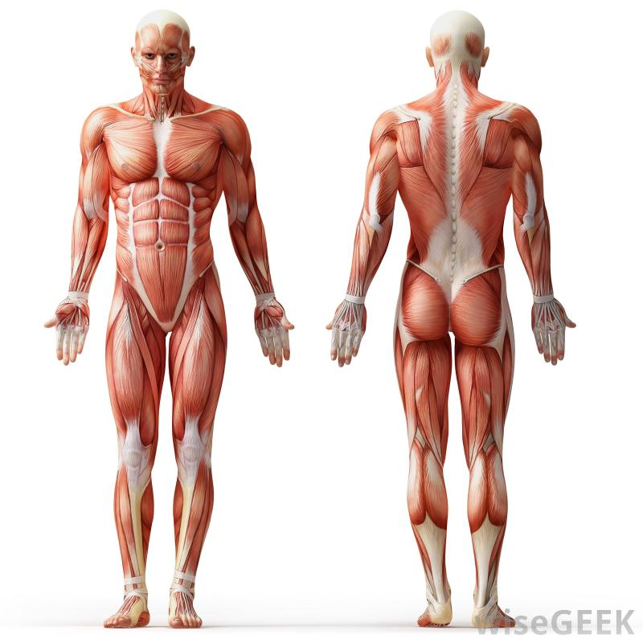
Back
Front

- Quadricep 8. Hamstring
- Gastrocnemius 9. Gluteus Maximus
- Trapezius 10. Latissimus Dorsi
- Pectoral 11. Deltoid
- Bicep
- Triceps
- Abdominals

